Information Processing Model
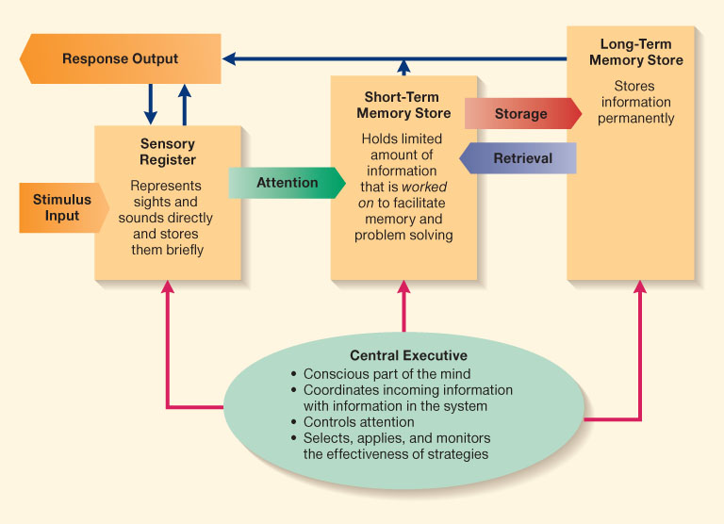
Information Processing: an approach that suggests that human mind is a symbol-manipulating system through which information flows, that often uses flowcharts to map the precise series of steps individuals use to solve problems and complete tasks, and that regards cognitive development as a continuous process.
Information processing theory suggests that the basic structure of the mental system is consistent throughout life. However, the capacity of the system that is, the amount of information that can be processed at once and the speed of processing increase until adulthood, however, it slows down and eventually declines after the adulthood. Middle-aged adults may not be able to process the same amount of information they used to process in young adulthood with the same speed.
Speed of Processing is the measurement of cognitive efficiency that involves the ability to automatically and fluently perform relatively easy or learned cognitive tasks.
As speed of processing declines with age, middle-aged individual’s information processing capacity also declines, which causes changes in cognitions.
Attention: a selective, controllable and limited cognitive process that is the ability to concentrate on a task while ignoring other environmental inputs, and contains many sub-processes specialized for different aspects of information processing. 3 types of attention: 1. selective attention (decline in midlife, but not significant) 2. Divided Attention & Attention Switching (declines the most in midlife) sustained attention (doesn’t change in midlife).
Central executive or executive functioning is the used for a goal-directed behavior. It directs the flow of information. The central executive is the conscious, reflective part of our mental system. It decides what to attend to, coordinates incoming information with information already in the system, and selects, applies, and monitors strategies.
Because of integrated executive functioning in midlife, practical problem-solving is better in midlife due to accumulated knowledge and experience.
Abstract: a multiple information processing systems and cognitive systems account in which separate aspects of information processing such as speed of processing, memory, attention, and executive functioning are differentially affected by aging, and lead to different changes in problem solving, creativity, and cognition in general. Although there are declines in speed of processing, and some types of attention and memory with age, however middle-aged adults are better at selecting information or focusing on particular aspects of tasks, and matured executive functioning compensates for their declines or changes in other aspects of information processing. However, clear markers of information processing changes and cognitive changes remain unclear or impossible to pinpoint because of a lack of research, as well as inter and intra-individual variability.

